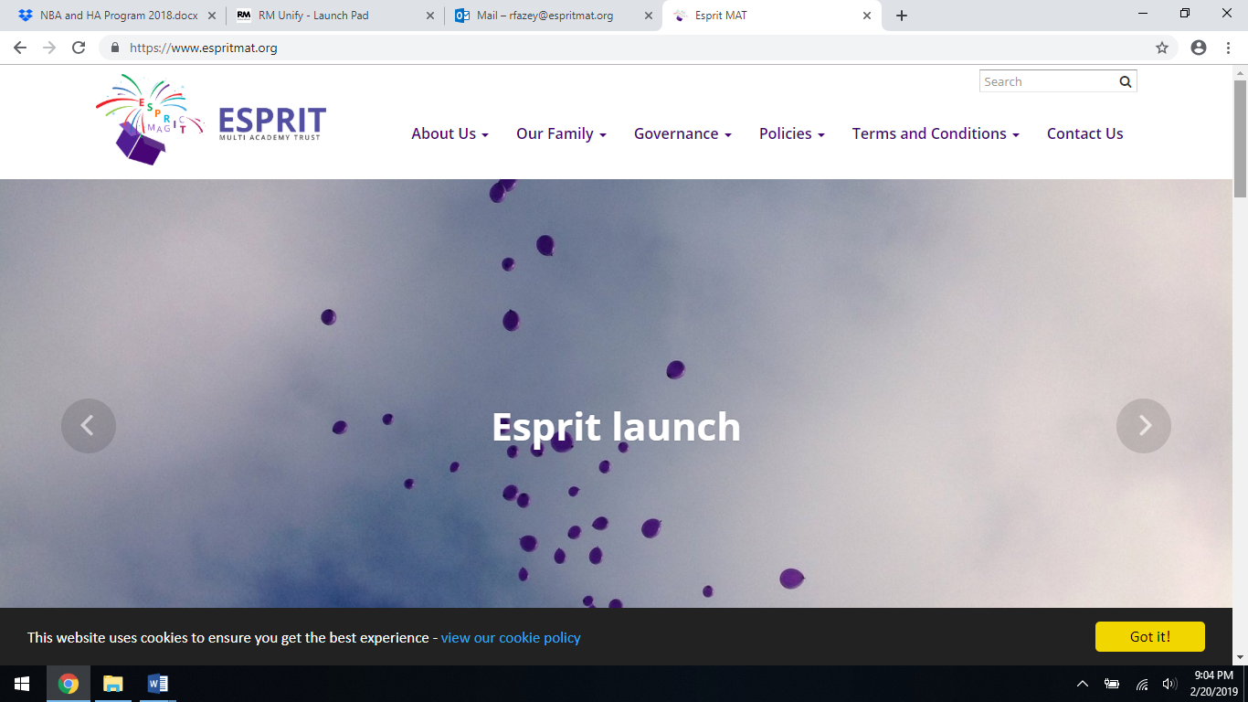

**Sports Day Thursday**

**23rd May 2019**

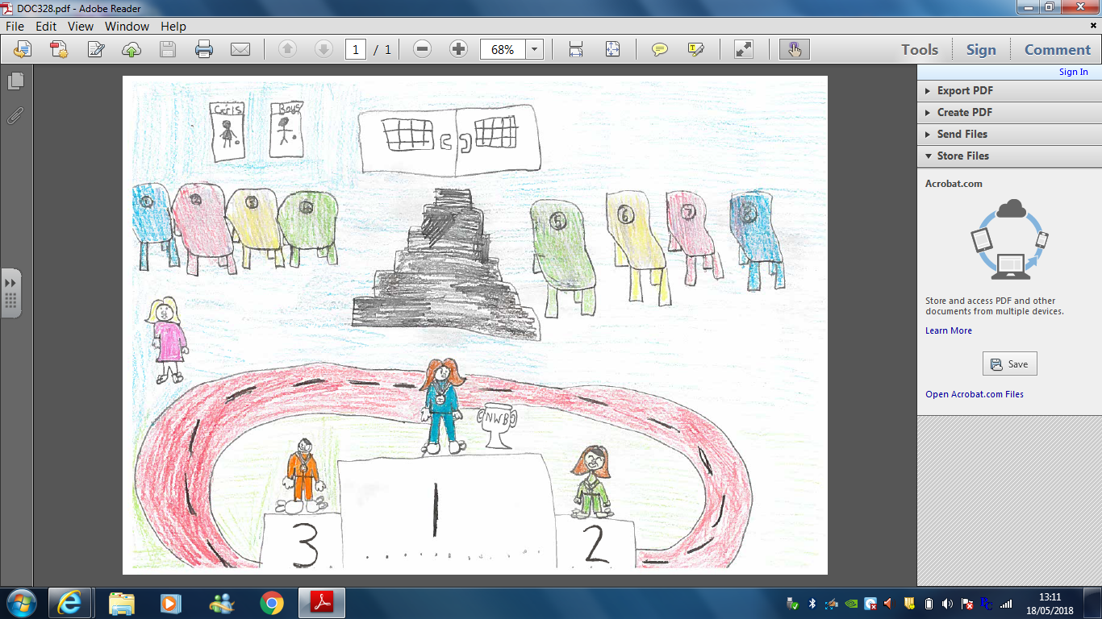

‘If you can dream it, you can do it, now go

out there and change the world!’