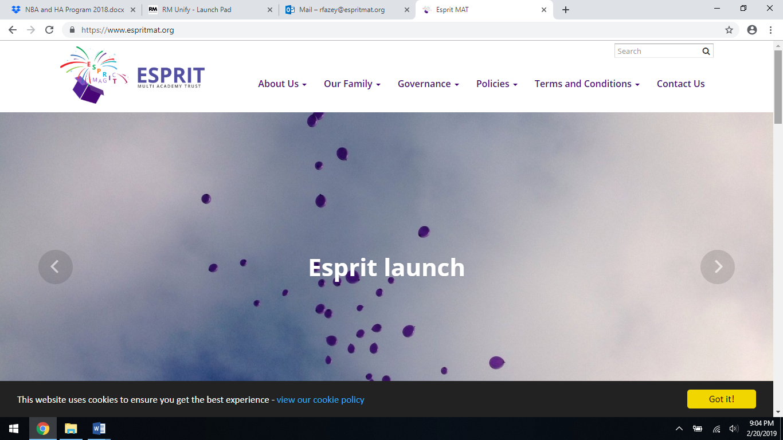

**Sports Day Tuesday**

**21st May 2019**

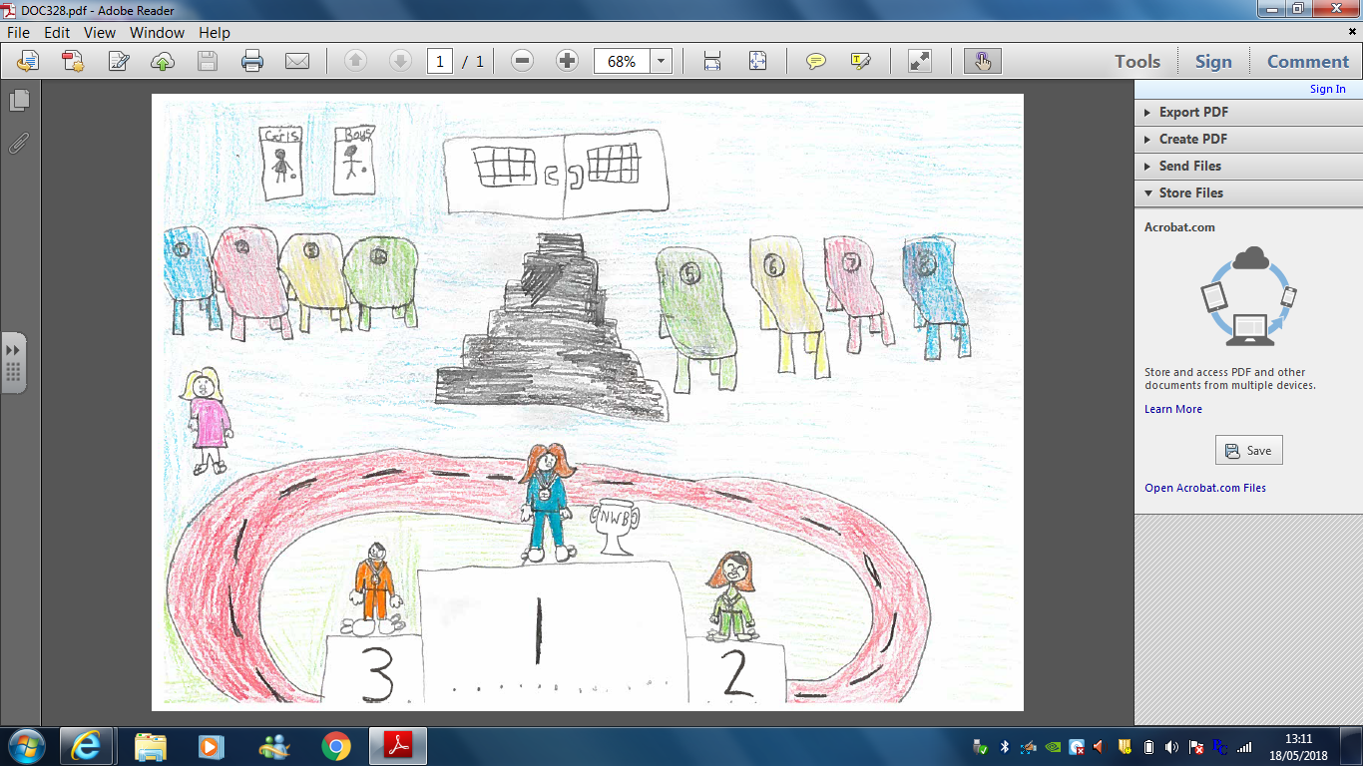

‘If you can dream it, you can do it, now go

out there and change the world!’